**Chapter 7 Exercises**

7.1.1 Add Screens to HMI Project 3

1) Add and Name additional screens for later use. 3

7.2.1 Setup the Overview Area and Template_1 5

1) Set up the Overview area and add objects to Template_1. 5

7.3.1 Configure Screen Navigation 10

1) Enable the Left Slide-in Screen and add Screen Navigation. 10

7.4.1 Setup TP700 COMFORT for Ethernet Transfer and Control 13

1) Change the HMI Panel Settings for Ethernet Control. 13

7.4.2 Setup the PG for Transfer and Download 15

1) Set the PG Download settings and Download to HMI. 15

7.5.1 Add a Text List to the Project 18

1) Add a Text List to control the Motor Start/Stop Button. 18

7.5.2 Add a Graphics List to the Project 19

1) Add a Graphics List to control the Motor Start/Stop Button. 19

7.6.1 Setup the Drive Control Screen for Drive Operations 21

1) Add Text and I/O objects to the Drive Control Screen. 21

2) Make PLC program changes to allow for HMI control 22

3) Add a button to the Drive Control Screen to execute axis commands. 22

4) Add a Direction Control Switch to the Drive Control Screen. 24

5) Add Motor direction Graphic I/O to the Drive Control Screen. 25

**7.1 Create Screens for Later Use**



**Description**

In this exercise, Screen 1 will be renamed to Start Screen and 4 additional screens will be created for later use.

**Objectives**

Upon completion of this exercise, the student shall be able to:

* Rename a Screen
* Add Screens

**Prerequisites**

The following prerequisites must be completed before this exercise is started:

* Chapter 6 exercises have been completed, or the Chapter 7 Seed Project Archive has been retrieved and opened for editing.
  + 1. Add Screens to HMI Project

|  |
| --- |
| 1. Add and Name additional screens for later use. 2. Open “Screens” folder. Change the name of the default Screen_1 to read “Home Screen”. Note that this is application start screen denoted by the green triangle. If it is NOT the start screen change it by right clicking it in the project tree then select “Define as start screen”. Do not add any text to the screen at this time, and associate the screen with NO Template. 3. Double-click on the “Add New Screen” entry in the Project tree.  * **Note: This will create a new screen with a default name of “Screen_<#>”.**  1. Rename the Screen to “Drive Control”. 2. Add a Text Field to the screen. 3. Edit the text to match the screen name. Set any Appearance and Text Format as desired. 4. Access the screen properties in the Inspector window. Assign Template_1 as the screen template.      1. Add another screen. Rename the screen “Alarms”. Add a Text Field to the screen. Edit the text to match the screen name. Set any Appearance and Text Format as desired, and associate the screen with Template_1. 2. Add another screen and rename it “Enhanced Objects”. Add a Text Field to the screen. Edit the text to match the screen name. Set any Appearance and Text Format as desired, and associate the screen with Template_1. 3. Add another screen and rename it “Trend”. Add a Text Field to the screen. Edit the text to match the screen name. Set any Appearance and Text Format as desired, and associate the screen with Template_1.   *This completes Exercise 7.1.* |

**7.2 Create an Overview Area**

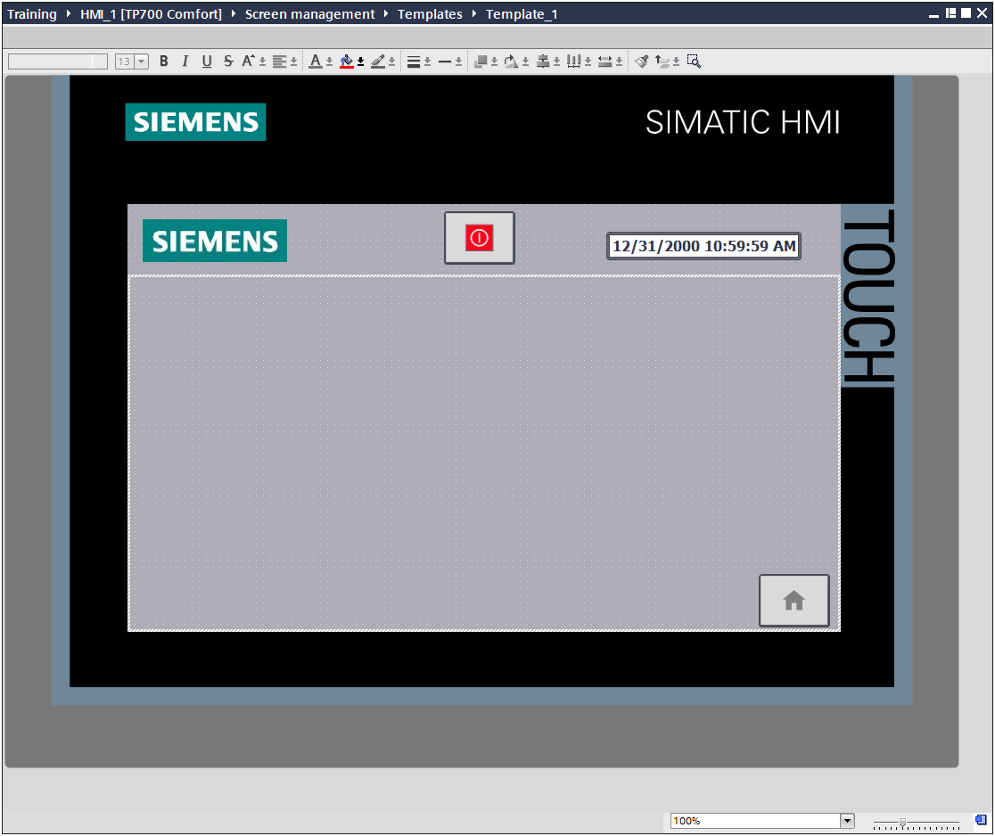

**Description**

The project provides a template for each one of the HMI devices. Multiple templates can be added if desired. Using a template, you can locally program the soft keys and objects for your project. All screens based on this template contain the objects and soft keys you have configured in this template. Changes to an object or of a soft key assignment in the template are applied to all object instances in the screens which are based on this template.

In this exercise, the Overview area will be setup on Template_1.

**Objectives**

Upon completion of this exercise, the student shall be able to:

* Setup the Overview area on Template_1.

**Prerequisites**

The following prerequisites must be completed before this exercise is started:

* Exercise 7.1 has been completed.

7.2.1 Setup the Overview Area and Template_1

|  |
| --- |
| 1. Set up the Overview area and add objects to Template_1. 2. In the Project tree, expand the branch labeled Screen Management. Expand the branch labeled Templates. 3. Open the Template_1 screen for editing by double-clicking. 4. At the top of Template_1, position your mouse so that a “double-headed arrow” appears. This indicates the “edge” of the Overview Area. Drag the line down to create an overview area. 5. From the Toolbox, select Basic objects. Click on the Graphics View  item, and then click on the Overview area to insert the item.  * **Note: The desired graphic is selected in the Properties pane of the Graphics View.**  1. With the Graphics view selected, access the object Properties in the Inspector window. 2. Under “General”, click on the small button on the lower left “Create New Graphic from File” . When the dialog opens, browse to the “Libraries”, “Pictures” folder. Select the file labeled “Siemens Logo”, then click “Open”. The new graphic item will be displayed. Resize as necessary.      1. From the Toolbox pane, “Elements”, then select the item “Date-Time Field”. 2. Add the object to the Overview area. 3. **NOTE – If it is necessary to resize the Date-Time object, you must disable the “Fit object to content” setting under “Properties, Layout”.** 4. From the “General” tab, make the following settings to display the HMI system date and time:      1. In the task card, access the Libraries tab. 2. Open the “Buttons-and-Switches” library. 3. Expand the branch labeled “Master copies”, then expand “SystemButtons”. 4. Expand the branch of SystemButtons labeled “Rectangular_small”. From the list of buttons, drag and drop the “SB_ExitRuntime_80x60” button onto the Overview area. This button includes the event required to stop runtime already configured. 5. Resize the button as desired.      1. Add a “Home” button to the Template_1 screen. Use the button with the name “SB_NavigateHome_80x60” button. Add the button to the lower right hand corner of the Template_1 screen.      1. Access the Properties of the Home button. Add an “Event” so that when the Home button is “Pressed”, the button with perform the function “ActivateScreen”.      1. Choose the screen “Home Screen” as the desired screen.   *This completes Exercise 7.2.* |

**7.3 Develop Basic Screen Navigation**

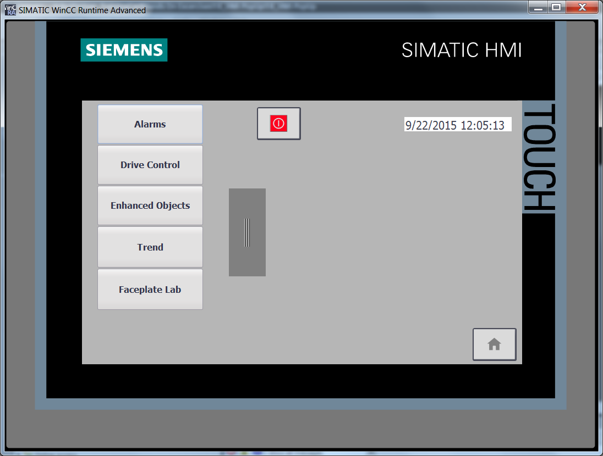

**Description**

You can easily use “drag and drop” to define the screen change. From the Start Screen, you switch to the individual plant screens, such as the fill level display. From each plant screen, you return to the start screen.

In this exercise, the Start Screen will be setup to navigate to all other screens.

**Objectives**

Upon completion of this exercise, the student shall be able to:

* Add screen navigation to other screens.

**Prerequisites**

The following prerequisites must be completed before this exercise is started:

* Exercise 7.2 has been completed.

7.3.1 Configure Screen Navigation

|  |
| --- |
| 1. Enable the Left Slide-in Screen and add Screen Navigation. 2. From the Project tree, expand the branch labeled "Screen management."      1. Under "Slide-in screens", double-click the Left Slide-in screen to open it for editing. 2. Access the Slide-in screen Properties in the Inspector window. Enable the Slide-in screen for use.      1. Access the "Handle" property. Note the handle is set to "Hide automatically".      1. Using drag and drop the window “Drive Control” onto the screen. This will automatically create a navigation button to activate that screen. 2. Repeat the procedure until buttons have been added for Enhanced Objects, Alarms, and Trend. 3. Select all of the newly added buttons. Change the button sizes and other properties as desired. Making a change will impact all selected buttons. 4. Resize and position the buttons as desired. Make note of the alignment aides that appear when moving the objects, making them easier to align     *This completes Exercise 7.3.* |

**7.4 Configure Download Settings**

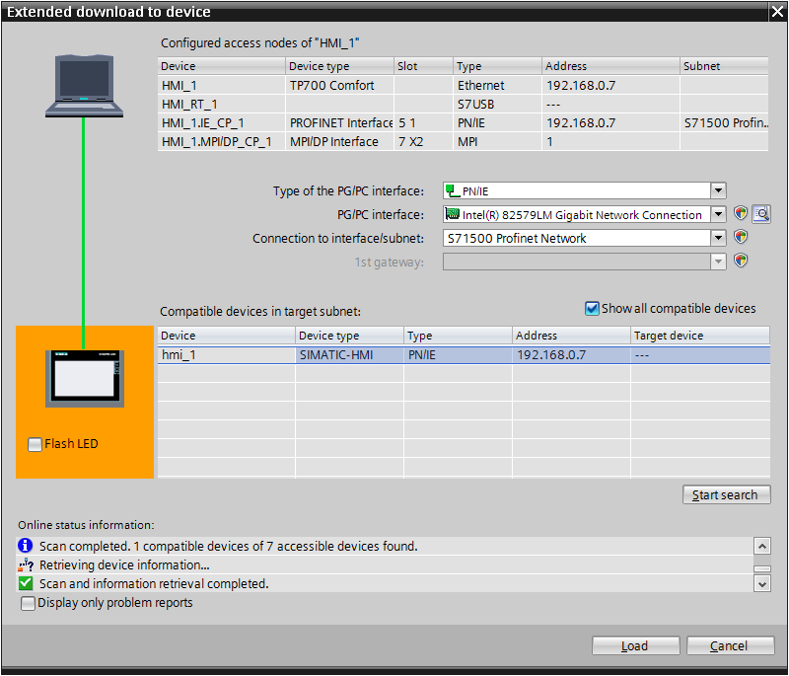

**Description**

You can set unique transfer settings for each HMI device in your project via the Extended Download to Device dialog. If you would like to transfer multiple devices, you can select them using “Shift-click” and each device will then be transferred via its transfer setting.

The configuration PC and HMI device are located in a network or are connected point-to-point. The transfer operation between the configuration PC and the HMI device takes place by means of an Ethernet connection.

In this exercise, the transfer settings will be configured on the TP700 COMFORT and PG. The HMI Project will be transferred and tested on the panel.

**Objectives**

Upon completion of this exercise, the student shall be able to:

* Configure Transfer Settings on the TP700 Comfort.
* Configure Download Settings on the PG.
* Transfer the HMI Project to the TP700 Comfort
* Test Screen Navigation on the HMI

**Prerequisites**

The following prerequisites must be completed before this exercise is started:

* Exercise 7.3 has been completed.

### 7.4.1 Setup TP700 COMFORT for Ethernet Transfer and Control

|  |
| --- |
| 1. Change the HMI Panel Settings for Ethernet Control. 2. From the Loader screen of the TP 700, press the Settings button.      1. Find the Icon Labeled “Transfer” and double click it. 2. Make sure the “Transfer channel” is set to PN/IE, and is set for “Automatic”      1. Click the “Properties…” button. A window will appear showing the network interface for the panel.      1. Double-click the LAN icon to open the properties dialog. 2. From the IP address tab, select “Specify an IP Address”, and set the address to 192.168.0.7      1. Click the OK button. 2. Exit out of the LAN interface window. 3. This will return you to the Transfer Settings dialog. Click on **OK** to accept the settings. 4. Exit Control panel, which will return you to the Loader. 5. Select “Transfer” from the Loader menu. |

### 7.4.2 Setup the PG for Transfer and Download

|  |
| --- |
| 1. Set the PG Download settings and Download to HMI. 2. Select the HMI object from the project tree. 3. Click the “Download” button. The “Extended download to device” dialog appears. 4. Select “PN/IE” as the “Type of PG/PC interface”. 5. Select the interface you have been using to access the rack as the “PG/PC interface”. 6. Select “Connection to interface/subnet” of ”S71500 Profinet Network”.      1. Click “Load” to start the download. The project will compile prior to the download.      1. When the compilation completes successfully, the Load preview dialog box will appear. Leave the “Overwrite” option unselected, then click “Load” to download the project to the HMI.      1. Test screen navigation on the HMI   *This completes Exercise 7.4* |

**7.5 Create Text and Graphics Lists**

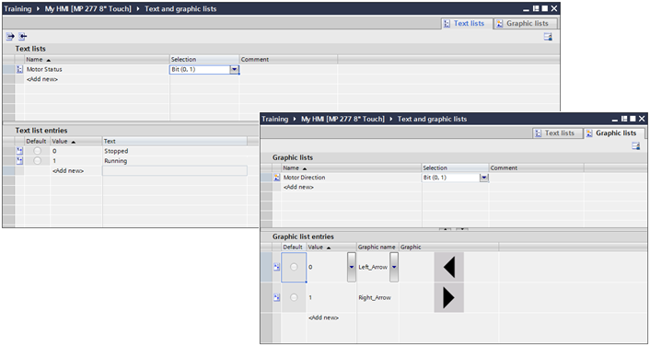

**Description**

In a text list, the values of a tag are assigned to various texts. The text lists are created in the "Text lists" editor. The attachment of the text list to a tag is configured on the used object, for example on a symbolic IO field.

In a graphics list, the values of a tag are assigned to various screens or graphics. The graphics lists are created in the "Graphics lists" editor. The attachment of the graphics list to a tag is configured on the used object, for example on a symbolic graphic field.

In this exercise, a Text List and a Graphics List will be created for use in the next exercise.

**Objectives**

Upon completion of this exercise, the student shall be able to:

* Create a Text List
* Create a Graphics List

**Prerequisites**

The following prerequisites must be completed before this exercise is started:

* Exercise 7.4 has been completed.

7.5.1 Add a Text List to the Project

|  |
| --- |
| 1. Add a Text List to control the Motor Start/Stop Button. 2. From the Project tree, double click on “Text and graphics lists” to open the editor. 3. In the Text and graphics list editor, select the “Text lists” tab. 4. Click in the “Add new” field. 5. Change the default name to read “G120 Speed Change Button Text”. 6. From the “Selection” pull-down menu select “Bit (0,1)”. 7. Add a description to the “Comment” Section. 8. Under the “text list entries” double click on <Add new>. 9. Add “Press to Execute” to the “Text” column for value “0” 10. Double click on <Add new> to a second value. 11. Add “”Executing” to the “Text” column for value “1” |

7.5.2 Add a Graphics List to the Project

|  |
| --- |
| 1. Add a Graphics List to control the Motor Start/Stop Button. 2. With the Text and graphics list editor open, select the tab “Graphics lists”. 3. Add a new Graphics List by adding “G120 Direction” to the Name Field. 4. From the “Selection” pull-down menu select “Value/Range”. 5. Add a description to the “Comment” Section. 6. Under “Graphics list entries”, double click on <Add new>. 7. Using the pull down menu, select the object “Right_Arrow: for a value of 1. 8. Add another graphic for a value of “2”, this time selecting “Left_Arrow”.     *This completes Exercise 7.5.* |

**7.6 Configure the Drive Control Screen**

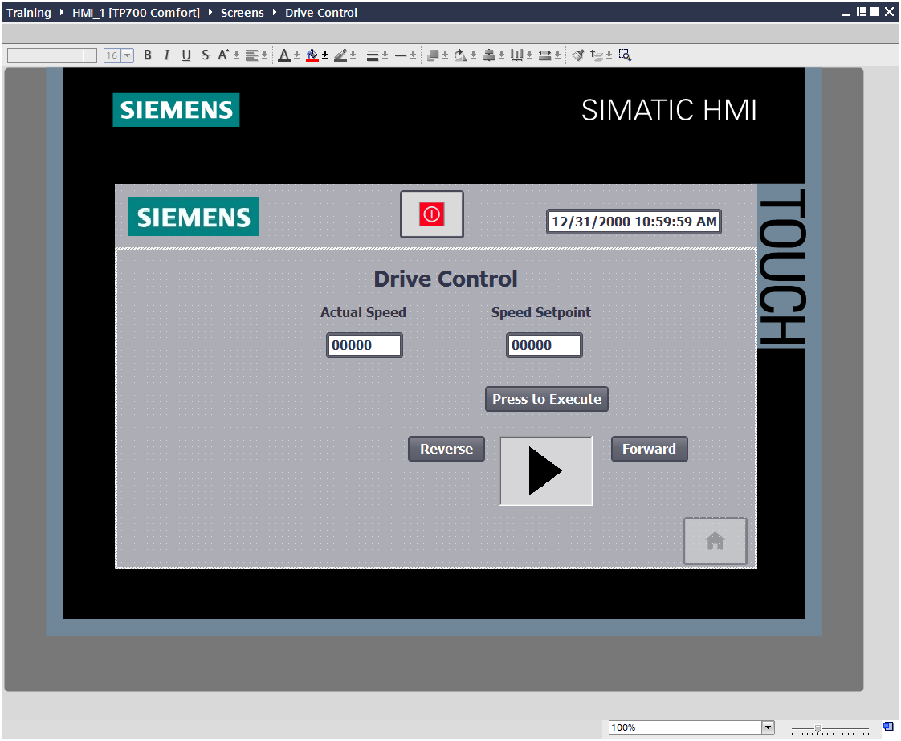

**Description**

In this exercise, the Drive Control screen will be setup to control the basic functions of the SINAMICS G120 Drive from the TP700 Comfort. Simple Objects will be added, assigned tags, and tested for proper functionality.

**Objectives**

Upon completion of this exercise, the student shall be able to:

* Configure a Button.
* Configure a Switch.
* Configure I/O Fields
* Add Control tags to the Project

**Prerequisites**

The following prerequisites must be completed before this exercise is started:

* Exercise 7.5 has been completed.

7.6.1 Setup the Drive Control Screen for Drive Operations

|  |
| --- |
| 1. Add Text and I/O objects to the Drive Control Screen. 2. Open the Drive Control Screen for editing. 3. From the Toolbox, place two text fields and label them Actual Speed and Setpoint Speed. Change their properties as desired.      1. Access the TO Axis DB of the S7-1500 PLC_1. Drag and drop the tag “ActualSpeed” and drop it onto the Drive Control screen under the corresponding text field. 2. Access the new I/O field’s Properties in Inspector window. Make the Actual Speed field “Output” only.      1. Open the “My Global Data” DB in the S7-1500 PLC_1 for editing. 2. Add an element of data type INT named “G120 Speed SP from HMI”. Drag and drop this element onto the Drive Control screen under the corresponding text field. 3. Observe the new IO field properties. Note the field is created as “Input/Output” mode. |
| 1. Make PLC program changes to allow for HMI control 2. Return to “My Global Data” DB in the S7-1500. 3. Add a BOOL Element named “G120 HMI Execute Speed Command” 4. Add an INT element named “G120 HMI Direction Command”. **Set the “Start value” to 1.** 5. Download the changes to “My Global Data” 6. Open the FB_Motion block in the S7-1500 for editing. 7. Make the changes to the MC_MOVEVELOCITY” as shown below.      1. Download your charges to the PLC. 2. Add a button to the Drive Control Screen to execute axis commands. 3. Return to the Drive Control screen and lace an Element of type Button on the screen. 4. In the Properties in the Inspector window, select “General”, and then select “Label” properties to display a Text List. 5. Select the text list “G120 Speed Change Button Text” from the pull-down menu. 6. Select the Process Tag by browsing to the S7-1500 and accessing “My Global Data”. Select “My Global Data”.”G120 HMI Execute Speed Command” from the pull-down menu.      1. Under the “Events” list, set the “Press” operation to the function “SetBitWhileKeyPressed” and link it to the data block value “My Global Data”.”G120 HMI Execute Speed Command”.      1. Your Drive Control screen should resemble the figure below: |

|  |
| --- |
| 1. Add a Direction Control Switch to the Drive Control Screen. 2. Place another Button on the screen. 3. Set the button “General” – “Mode” property to “Text.” 4. Under “Label”, label the button to read “Forward” 5. Under the “Events” list, create a “Press” event of type “SetTag”. Link the event to the “My Global Data”.“G120 HMI Direction Command” tag with a value of “1”.      1. Add another button. Change its label to read “Reverse” 2. Under the “Events” list, create a “Press” event of type “SetTag”. Link the event to the “My Global Data”.“G120 HMI Direction Command” tag with a value of “2”.      1. Your “Drive Control" screen should resemble the figure below: |
| 1. Add Motor direction Graphic I/O to the Drive Control Screen. 2. From the Toolbox, under Elements, add a “Graphic IO Field” to the screen. Link the process tag to Global Data”.“G120 HMI Direction Command” tag. 3. Link the Graphics list to “G120 Direction”.      1. Your Drive Control Screen should resemble the figure below:      1. Transfer the Project and Test functionality. REMEMBER – the drive axis is enabled from the KP8! Note that for any speed or direction change, the “Press to Execute” button must be pressed.   *This completes the Chapter 8 Exercises* |